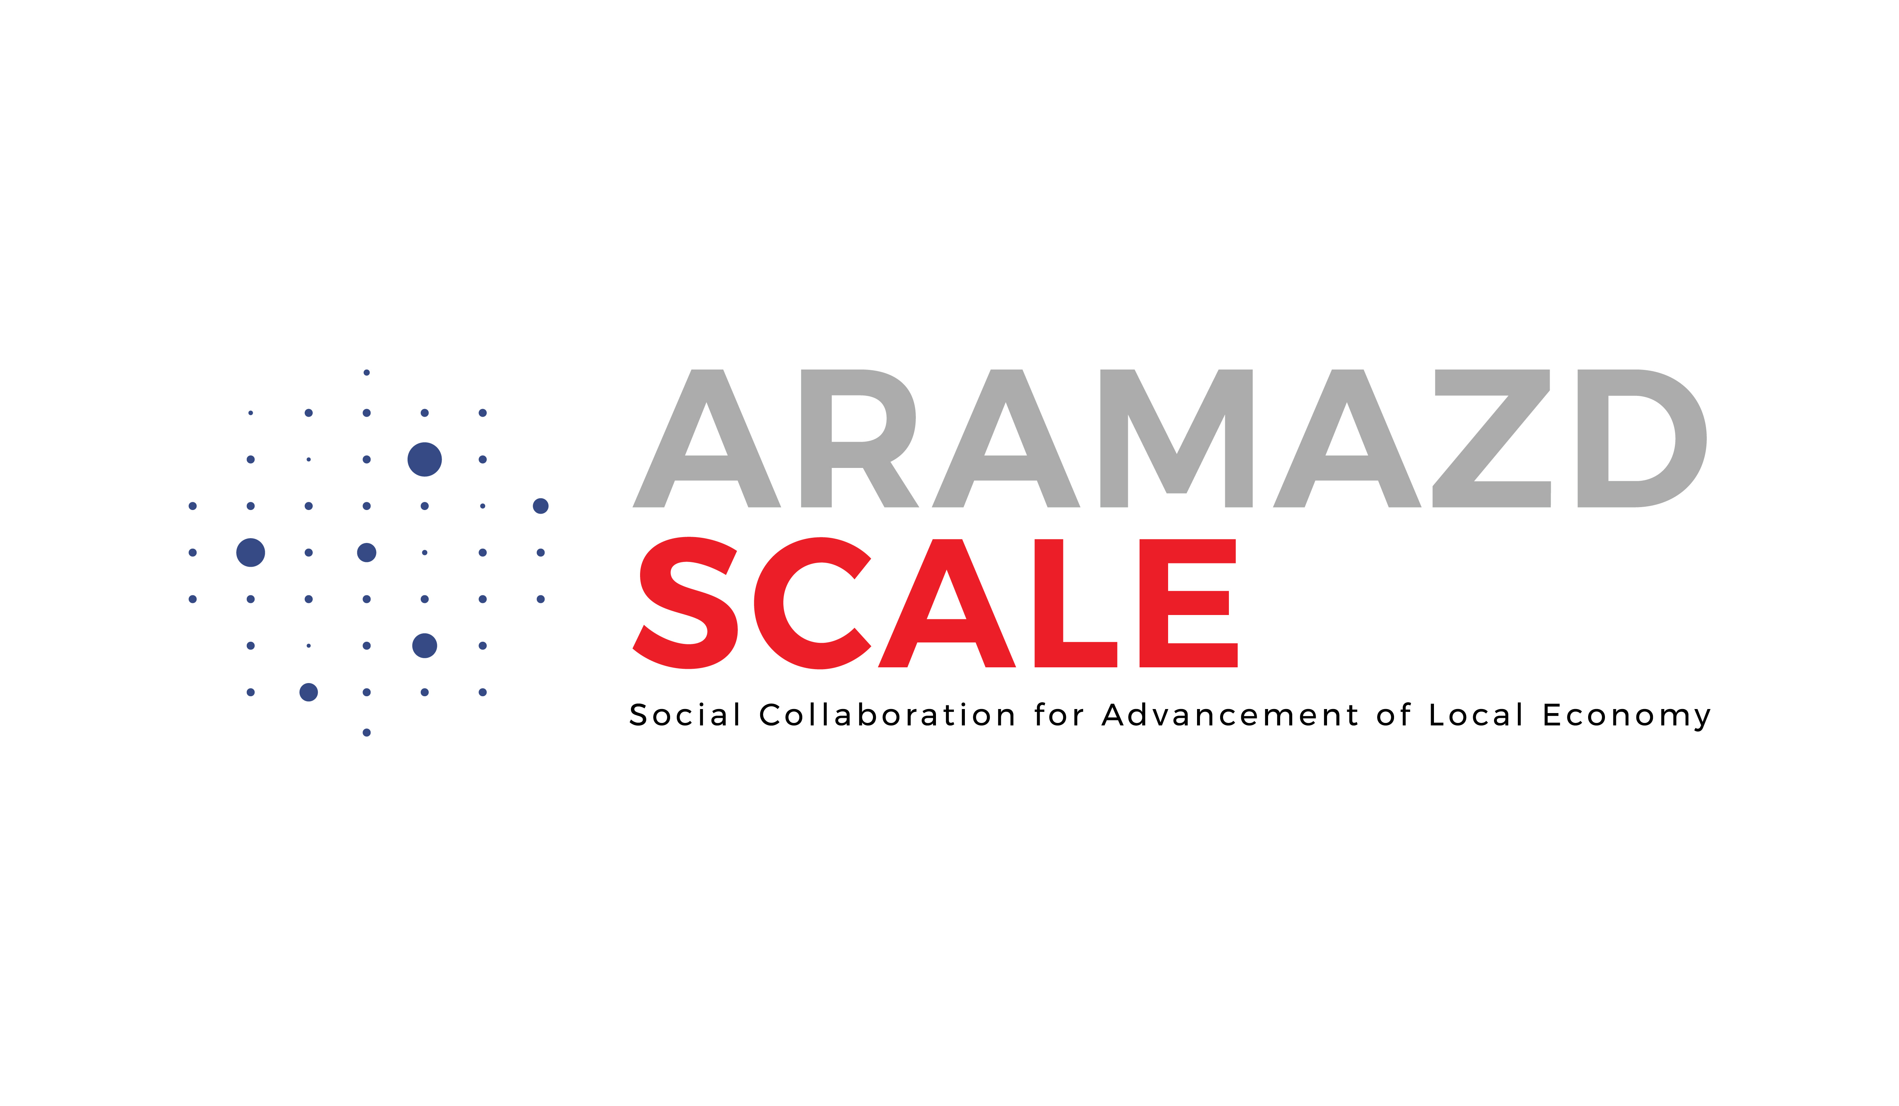

Terms of Reference (ToR)
Development of Armenia’s Social Economy Criteria Framework
Position: | Social Economy Policy Specialist
Duration: | 3 months (12 weeks)
Engagement Type: | Individual Expert Consultant or Team
Commissioning Organization: | Armenian Caritas Benevolent NGO
Audience for the final product: | AC, Government institutions (national, regional and local), private sector, CSOs, academia, and other stakeholders.
Purpose: | Produce a practical and concise draft policy framework, defining essential Social Economy criteria for Armenia, aligned with Caritas Europa and EU standards, and ensuring conformity with the Armenia’s legal and policy context. The output will be ready for multi‑stakeholder validation and will serve as a basis for future state recognition of SE.

Background
Armenia is advancing inclusive local development and decentralization while facing social and economic vulnerabilities in rural and border regions. “ARAMAZD. SCALE” project of Armenian Caritas prioritizes national recognition of the Social Economy through a contextualized criteria framework, co‑created with state, private and civic actors. A clear, locally owned framework (definition, eligibility criteria, governance, transparency, and impact requirements) is a prerequisite for downstream legislation, tailored support measures, and integration into public policies and community development plans.
Currently, Armenia lacks:
- Clear legal definition and recognition framework for social economy entities
- Tailored support mechanisms for SE development
- Integration of SE principles into national and local development strategies
- Alignment with EU social economy standards and Caritas Europa values

Objective
Design a comprehensive National Social Economy Recognition and Support Framework that strengthens Armenia’s policy foundation for social economy development and fosters an enabling environment for sustainable SE growth։
- Sets a country‑adapted definition of SE entities consistent with EU practice and Caritas Europa values.
- Establishes eligibility criteria (mission, governance, profit allocation, reinvestment, transparency and accountability, stakeholder participation, public benefit, and impact measurement).
- Proposes policy and regulatory options (recognition, fiscal and procurement measures, access to finance, support services) aligned with RA strategies.

Specific Objectives

Recognition: Develop basic and practical criteria for identifying SE entities within Armenia’s context.

Support: Discover modest support measures that are feasible and aligned with Social Economy principles.

Integration: Encourage gradual inclusion of SE concepts into relevant policy areas.

Sustainability: Focus on ensuring the framework’s realistic application within current institutional capacities.

Alignment: Seek progressive alignment with EU practices and Caritas Europa values where applicable.

Expected Impact
- Short-term: Policy framework ready for multi-stakeholder validation and submission for legislative consideration
- Medium-term: Increased SE entity registration and support uptake
- Long-term: Measurable contribution to inclusive economic development

Key Definitions
All concepts will use Caritas Europa and EU SE vocabulary and will be checked for compatibility with RA legislation. A compact Glossary will be delivered and used consistently across all outputs.

Scope of Work
The consultant/team will complete three integrated workstreams.
 | Deliverables | Timeline
Workstream 1: | Foundational Research and Alignment | (Weeks 1–3)
- Inception Report: | - Detailed methodology and timeline  - Stakeholder engagement plan  - Alignment with Caritas Europa values | Week 1
- Mapping Report: | - Comprehensive mapping of Armenian legal & policy framework on Social Economy (SE)  - Identification of gaps with EU SE standards | Week 2
- Comparative Analysis: | - EU SE policy review & best practices  - Contextual adaptation for Armenia | Week 3
- Stakeholder Ecosystem Report: | - Stakeholder map (ministries, CSOs, local authorities, academia, private sector)  - Strategy for integrating Caritas Europa values | Week 3
Workstream 2: | Drafting the SE Criteria Framework | Weeks 4–10
2.1 Draft Definition & Scope: | - Nationally contextualized SE definition  - Entity categories, public interest objectives  - Safeguards against mission drift | Week 4-5
2.2 SE Criteria | - Mission & public benefit  - Democratic governance principles  - Profit distribution rules  - Transparency & accountability | Week 6
 | - Stakeholder engagement standards  - Proportionate impact measurement framework  - Environmental & social safeguards | Week 7
2.3 Policy Options Pack (Draft) | - Legislative amendment proposals  - Recommendations for integration into economic policies  - Alignment with decentralization strategies | Week 8
2.4 Multi-Stakeholder Consultation Draft: | - Revised SE Criteria Framework with stakeholder feedback  - Summary notes of consultations | Week 9-10
Workstream 3: | Finalization | Weeks 11–12
3.1 Revised Draft Framework: | - Incorporating national and EU-level feedback  - Ensuring consistency with Armenian decentralization reforms | Weeks 11
3.2 Draft Implementation Plan & Roadmap: | - Short-, medium-, and long-term actions  - Roles of government, CSOs, and communities  - Monitoring and evaluation framework | Weeks 11
Final Report & Presentation: | - Final SE Criteria Framework  - Policy Options Pack (legislative & policy recommendations)  - Implementation Roadmap  - Executive presentation for Caritas Armenia, government, and EU partners | Weeks 12

Team Composition, Qualifications
Social Economy Expert (Social Economy Economist, Policy Lead):
- 4 and more year experience in social, economic public policy; Armenian policy context;
- Minimum qualifications (team): Master’s degree, PhD preferable in Economics/Public Policy or similar; proven SE experience; track record in policy papers and multi‑stakeholder processes; familiarity with rural/border community needs; strong writing in plain language.
Legal Expert (RA law):
- 4 and more year experience; corporate, nonprofit law, tax, procurement; policy drafting.
- Minimum qualifications (team): Master’s in Law/Public Policy or similar; proven SE experience; track record in policy papers and multi‑stakeholder processes; familiarity with rural/border community needs; strong writing in plain language.

Coordination and Key Counterparts
Primary: Ministries of Labor and Social Affairs, Ministry of Economy (policy leads).
Close coordination with, Ministries of Territorial Administration and Infrastructure, Finance; relevant parliamentary committees; regional administrations and municipalities; CSO and cross-sectoral networks; academia.
The multi-stakeholder informal network, initiated and facilitated by the Aramazd project, brings together representatives from regional and local authorities, CSOs, businesses, and vocational education institutions (VETs). Since 2022, this group has played an active role in shaping the emerging Social Economy (SE) ecosystem in Armenia. Established in 2020, the network initially included 34 members from local self-government bodies, regional administrations, civil society organizations, and the private sector. Over the past five years, it has evolved in structure, gradually forming a core group of the most active and committed members. The network has been engaged in SE-related capacity-building, participatory decision-making, and community-driven initiatives—contributing voluntarily through their expertise, local knowledge, and connections.

Methodology
- Evidence‑based desk research using official RA sources and EU/Caritas documents.
- Co‑creation with state counterparts; structured consultation instruments; comment log.
- Engagement and cooperation with the project multi-stakeholder network.
- Plain‑language drafting with visual summaries; bilingual deliverables.
- Do‑no‑harm & inclusion: gender, youth, disability, environment integrated.

The methodology emphasizes an inclusive, participatory co-creation process facilitated by the project team through:
- Thematic roundtables and multi-stakeholder consultations to define SE policies and legal frameworks.
- Community-based needs assessments involving local authorities and CSOs to identify social and environmental challenges.
- Workshops and training to ensure the participation and capacity development of all stakeholders, from grassroots actors to policy-makers.

Acceptance Criteria
- Terminology fully consistent with Caritas Europa and EU SE usage; Glossary delivered.
- Framework includes clear, testable criteria and administrative options for recognition.
- Policy options are feasible in RA context.
- Stakeholder feedback transparently integrated (feedback log).

Reporting, Payments Schedule
- 20% after Inception Package (W1) approval.
- 40% after delivery of Draft SE Criteria Framework (W9).
- 40% after Final Framework (W12).

Ethics, Data, IP
- Use public and official sources; comply with personal‑data rules when collecting stakeholder inputs.
- All outputs are the intellectual property of the commissioning organization; open sharing with state partners is permitted.
- All processes and deliverables will be implemented in accordance with Armenian Caritas guidelines.

Annex Outline (to be delivered)
- Annex A: Glossary (Caritas Europa & EU‑aligned; EN/AM).

Application Procedures
Interested candidates are invited to submit a complete application package that includes the following documents:

Required Documents:
- Detailed CV: A comprehensive CV or CVs in case of a team highlighting relevant professional experience.
- Annex 1-Technical proposal: Include a clear description of relevant experience, methodology, approach and team composition /for team applications/.
- Annex 2-Financial Proposal: Include a detailed budget outlining the costs of each workstream.

Submission Instructions
- All application documents must be submitted via email to z.aghanyan@caritas.am and info@caritas.am
- The subject line of the email should read: "Social Economy Expert: ARAMAZD – Your/ team Name"
- Applications must be received no later than November 5, 2025

Important Notes
- Shortlisted candidates will be contacted for an interview
- Applications that do not include all required documents or fail to meet the deadline will not be considered
- All created materials will be the intellectual property of Armenian Caritas.

