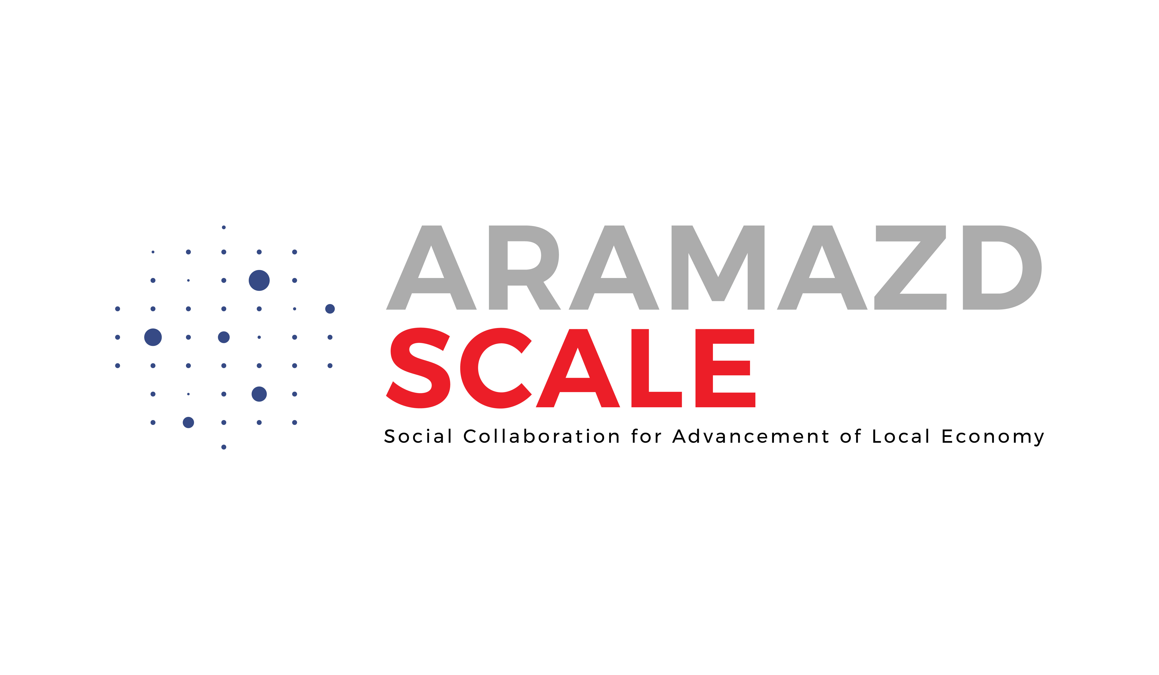

Technical Proposal

1. Introduction
Briefly introduce yourself/team. Mention your understanding of the Social Economy Criteria Framework development and its importance for Armenia.

2. Relevant experience
Briefly describe your/team’s experience in the Social Economy sector. Mention your involvement in projects, initiatives, or activities related to SE and its development in Armenia. Describe your general expertise and how it relates to the objectives of the assignment.

3. Methodology and Approach
Explain the methodology you will use to carry out the tasks. Highlight how you will ensure participation, inclusiveness, and alignment with Caritas Europa and EU Social Economy standards.

4. Team Composition (if applicable)
Describe the composition of the team, specifying the roles and responsibilities of each member. Include relevant qualifications and experience that demonstrate the team's capacity.

