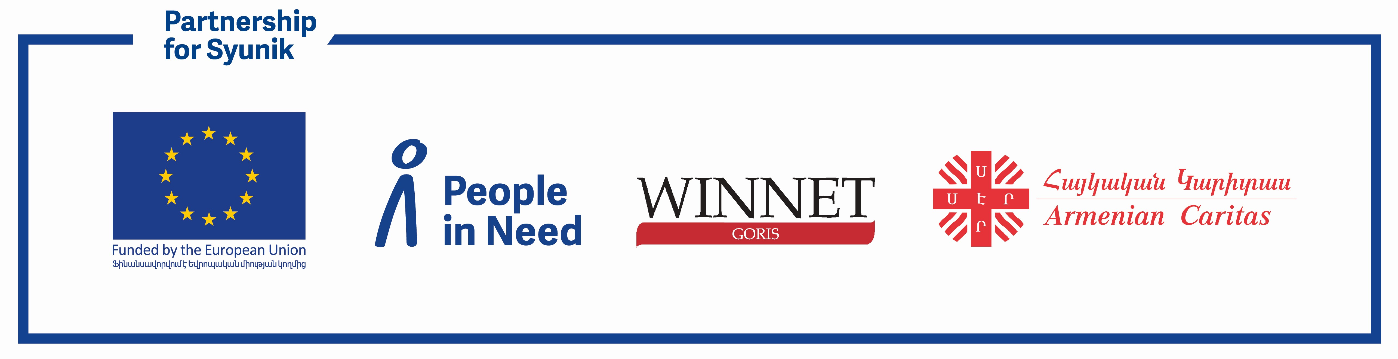

“PARTNERSHIP FOR SYUNIK: ENHANCED COMMUNITY-BASED SOCIAL SERVICES”

PROJECT

Terms of Reference (ToR)

**Specialist in evidence-based research and policy dialogue for supporting project-targeted CSOs in Policy Engagement**

**Background**

About the project: The "Partnership for Syunik: Enhanced Community-Based Social Services" project is part of the Team Europe initiative, funded by the European Commission. Its primary goal is to foster a more resilient and sustainable social service system in Syunik, Armenia. The project is implemented by People in Need in collaboration with the “WINNET Goris” Development Foundation and Armenian Caritas. The project focuses on three key objectives: enhancing the capacity of Civil Society Organizations (CSOs) to deliver high-quality social services; establishing sustainable mechanisms for participatory planning and service delivery in cooperation with local authorities; and advancing policy dialogue and advocacy for the long-term funding of community-based social services. These efforts aim to transition from a reactive, ad-hoc approach to a more cohesive and resilient social service system, tailored to the needs of Syunik's vulnerable populations.

Armenian Caritas leverages its advocacy expertise to support targeted capacity-building for CSOs, concentrating on evidence-based research, advocacy, policy dialogue, and monitoring. Through customized workshops, training and direct support, CSOs will gain the skills to assess policy frameworks, craft data-driven recommendations, and advocate for inclusive and effective reforms in social services. The project emphasizes strengthening CSO collaboration with stakeholders, including the Ministry of Labor and Social Affairs of RA.

To achieve these objectives, a Specialist will lead capacity-building activities to enhance the advocacy skills of project-targeted CSOs, enabling them to contribute meaningfully to public consultations during policy and legislative reforms. Additionally, the expert will support CSOs in advancing municipal-level initiatives, ensuring sustainable funding for community-based social services and fostering impactful, long-term solutions.

**Duration**

3 -4 months (service contract)

**Location**

Remote and In-person at Syunik province, Armenia

**Expected Start Date**

3rd of March, 2025

**Reporting to**

Project Manager of "Partnerships for Syunik. Enhanced Community-Based Social Services" project of Armenian Caritas

**Contract Type**

Service Contract

**Objective**

The Specialist will support project-targeted CSOs to:

* Enhance their understanding of legislative and policy processes.
* Strengthen their advocacy skills to effectively engage in policy dialogue with government in the face of the Ministries and adjacent structures, Parliamentarians, other.
* Provide meaningful, evidence-based contributions to social service legislation and policy reforms.
* Maintain policy engagement and capacity building activities of CSOs.

**Key Responsibilities**

Capacity Building:

* Conduct a needs assessment to identify gaps in advocacy skills and policy engagement capabilities of project-targeted CSOs.
* Design and deliver tailored training sessions and workshops, priorly agreed upon in with the project consortium team (PIN, Caritas), on advocacy strategies, policy analysis, and stakeholders’ engagement.

Policy Dialogue Facilitation:

* Organize and facilitate consultations between CSOs and State/Parliament representatives.
* Support CSOs in developing policy briefs, position papers, and recommendations to influence social service legislation.

Technical Assistance:

* Provide one-onto-one coaching and mentorship to CSOs on evidence-based advocacy planning and execution.
* Assist in the development of advocacy campaigns and communication strategies.
* Provide ongoing support and guidance to ensure a smooth procedure for target CSOs.

Monitoring and Evaluation:

* Track and report on the effectiveness of policy dialogue, advocacy and monitoring initiatives led by target CSOs.
* Document success stories and lessons learned to inform future interventions.

Follow-up & Troubleshooting:

* Provide follow-up support post-submission to Syunik based project-targeted CSOs to address any additional queries or requirements.
* Help resolve any issues or delays in campaign procedures.

**Deliverables**

Expected Outputs:

* Development of an interactive, practical training module focusing on CSO-led evidenced-based research;
* Training materials and workshop agendas;
* A minimum of 3 capacity-building workshops conducted in online and offline formats for Syunik project target CSOs;
* Follow up mentoring support for at least 15 Syunik CSOs engaged furthering their skills in advocacy and policy dialogue in the social protection sphere;
* Policy briefs or position papers co-developed with CSOs;
* Progress reports detailing activities, achievements, and challenges;
* Final report summarizing outcomes, recommendations, and sustainability plans.

**Required Qualifications and Skills**

* Advanced degree in Public Policy, Law, Social Sciences, or a related field;
* Minimum 5 years of experience in advocacy, policy analysis, or related fields;
* Proven track record of working with CSOs on policy engagement and capacity building;
* Excellent understanding of Armenia’s social service legislation and policy landscape;
* Strong facilitation, coaching, and interpersonal skills;
* Ability to produce high-quality written materials in Armenian and English;
* Experience in developing technical curriculum;
* Demonstrated knowledge of best practices in curriculum design, and effective assessment strategies;
* Ability to receive and incorporate feedback into course material from program and consortium leads;
* Ability to reliably meet deadlines while working with CSOs;
* Prior experience in dealing with government institutions or state authorities is highly desirable.

**Application Process**

Interested candidates are invited to submit their applications, including a detailed CV highlighting relevant experience, a cover letter outlining their approach to advocacy capacity building and policy engagement, and a sample of previous work, such as a policy brief or advocacy strategy and the approximate detailed budget of the assignment, as well as a workplan to the required documents, which will include activities, timelines and deliverables.

Applications must be submitted via email to and [info@caritas.am](mailto:info@caritas.am) and [d.miribyan@caritas.am](mailto:d.miribyan@caritas.am) no later than **February 10th, 2025**. Please include "Specialist in evidence-based research and policy dialogue: Your Name" in the subject line. Only shortlisted candidates will be contacted for further steps in the selection process.