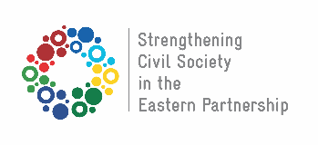
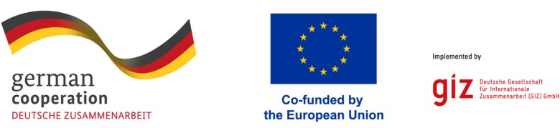

International Study Visit
From May 6th to 12th, 2024, an international study visit titled "Study on the Success of the Social Economy" will be held in Greece. We extend invitations to the key local stakeholders from Tchambarak community to participate in this international study visit.

The international study visit is being organized by "Armenian Caritas" Benevolent NGO within the framework of "Socio-Economic EcoSEstem Development in Tchambarak united Community" (EcoSE) project, in cooperation with the German Corporation for International Cooperation (GIZ) under the "Strengthening Civil Society in Eastern Partnership Countries" program. The program is funded by the German government and co-financed by the European Union (EU).

The aim of the Visit
The primary objective of the visit is to study the European experience in Social Economy comprehensively. Furthermore, participants will work to localize the acquired knowledge within Tchambarak community by implementing practical mechanisms.

Participants
The eligible participants for the study visit are the representatives from the LA, USS, local CSOs, SMEs and SEs in Tchambarak community, who are interested in the processes aimed at the development of the Social Economy, are invited to participate in the international study visit. Participation in the international study visit is by invitation, and the number of participants is strictly limited.

The Language of the International Study Visit
The international study visit will be conducted exclusively in English, without provision for simultaneous or consecutive translation.
Selection of Participants

The rule stipulates that each organization is entitled to appoint only one representative for the international study visit.

Selection Criteria
- Inclusivity: Representatives from Local Authorities (LA), United Social Service (USS), Civil Society Organizations (CSOs), Small and Medium Enterprises (SMEs), Social Entrepreneurs (SEs) who demonstrate an interest in studying and acquiring knowledge and experience in the field of Social Economy.
- Social skills: Applicants should display motivation to participate in the international visit, be open to new challenges, and demonstrate readiness to implement acquired knowledge.
- Networking: Candidates must be willing to actively engage in efforts directed towards the development of the Social Economy sector in the Tchambarak community through networking and collaboration.
- Sustainability: Applicants should be prepared to transfer or apply the acquired knowledge (knowledge management) within the local context of the partners in Tchambarak community, ensuring sustainability and long-term impact.
- Language proficiency: Fluent in English, both spoken and written, to facilitate effective communication and participation in the international study visit.

The program will encompass the expenses related to the international and local transportation of the selected participants, their accommodation, per diem, as well as the costs linked with acquiring a Schengen visa.

To submit an application for the international study visit, it is imperative to fill out the specified application form provided below (Application 1).

Applications should be sent to the designated email addresses provided below: d.miribyan@caritas.am
info@caritas.am
The deadline for submitting applications is March 20th, by 17:00 (Yerevan time).
ANNEX 1
International Study Visit
"Study on the Success of the Social Economy"
From May 6th to 12th, 2024, in Greece

APPLICATION

Name Surname

Organization name

The main field of the organization's activity.

The organization's period of activity.

Address

Phone Number

Email Address

Your role and function in the organization

Language proficiency | English  Verbal communication is poor.  The level of conversational and communicative skills is good.  Verbal and written communication is excellent.
Acquired Schengen visa | Yes | No
Participation in the study visit development programs | Yes  (Describe in the line below) | No
Participation in the study visit development programs.
Describe

Motivation of participating in the international study visit (Maximum 2 paragraphs)
How are you going to transfer or share the knowledge gained during the study visit among local stakeholders?

