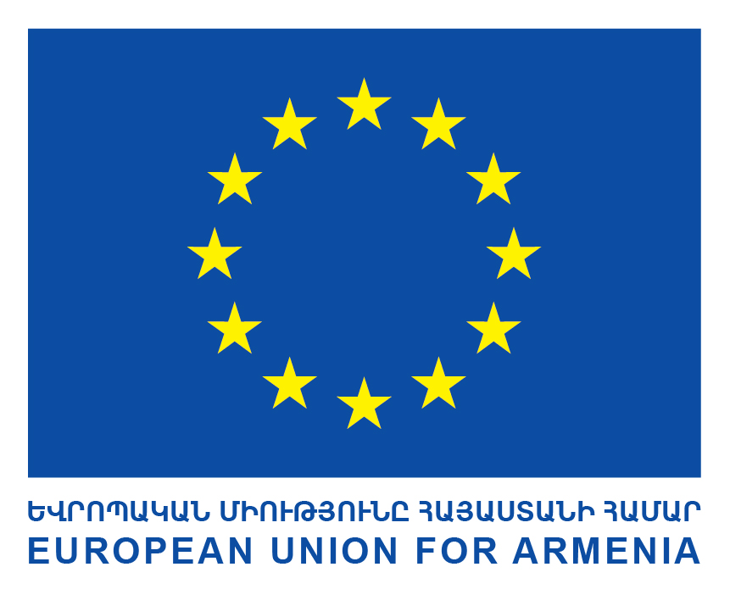
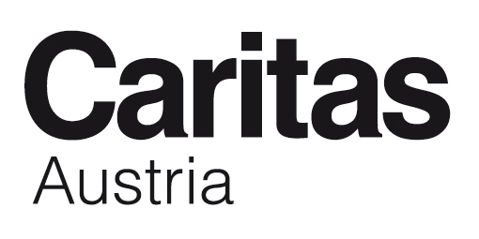
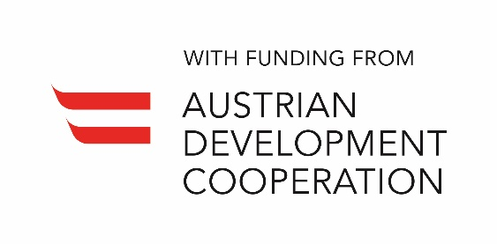

TERMS OF REFERENCE (ToR)

FINAL EVALUATION of the Action

“First inclusive and barrier-free Bakery and Coffee Shop in Gyumri”

BACKGROUND
Title of the Action to be evaluated | First inclusive and barrier-free Bakery and Coffee Shop in Gyumri
Country / Location | Armenia / Shirak marz (region)
Budget of the Action to be evaluated | Total project costs: EUR 299.097,00  EU Contribution: EUR 269.187,00  ADC Contribution: EUR 14.955,00  Caritas Austria Contribution: EUR 14.955,00
Project/Programme Number | European Commission: ENI/2016/382-286  Austrian Development Cooperation: 2325-08/2017  Caritas Austria: 1660038
Date of the Action to be evaluated | Start: 19.12.2016  End: 19.07.2019
Brief Description: Financed by the European Union, the Austrian Development Cooperation and Caritas Austria the project “First Inclusive and Barrier-free Bakery and Coffee Shop in Gyumri” promotes the inclusion of people with disabilities into labour market by depicting the disabled employees as assets. The action is coordinated by Caritas Austria and executed by its partner, Armenian Caritas.
The project has five major components:
- Inclusive Bakery and Coffee Shop.
- Herbal gardening.
- Training and cooperation.
- Therapeutic Handicraft work.
- Public Awareness Raising.

The action to be evaluated has the following Overall Objective (OO) and Specific Objectives (SO):
OO: To contribute to the financial sustainability and diversification of resources of the Emili Aregak Center
SO1: To set up a barrier-free and inclusive bakery and coffee shop in Gyumri
SO2: To promote the inclusion in the labour market of people with disabilities

Actions in Brief:
- A barrier free and inclusive environment of the Bakery and Coffee Shop provides the perfect setting to promote the employment of people with disabilities as their best employable attributes will be showcased.
- By engaging in manual work at the Emili Aregak center, people with disabilities can demonstrate their skills and abilities in growing and maintaining delicious and high quality herbs and vegetables.
- Empowering people with disabilities by providing them with the necessary training, support, opportunity for employment, and a pathway for their integration into the labor market.
- People with disabilities use their creative physical and mental abilities to create, design, and take part in the production of handicrafts.
- Increase the public’s awareness, including employers, of people with disabilities and their capability to become skilled and be employed in the labour market. Improve the public’s attitude and perspective about the rights of people with disabilities.
For more information please refer to the logframe of this Action and to the project documents that will be made available upon assignment.

DESCRIPTION OF THE EVALUATION ASSIGNMENT

Type of evaluation | Final evaluation
Coverage | the Action(s) in its entirety
Geographic scope | Gyumri and Shirak region – most of the project activities are located in Gyumri
Period to be evaluated | the entire period of the Action to date

  - Objectives of the evaluation
Systematic and timely evaluation of its programmes and activities is an established priority of the European Commission. The focus of evaluations is on the assessment of achievements, the quality and the results of Actions in the context of an evolving cooperation policy with an increasing emphasis on result-oriented approaches and the contribution towards the implementation of the SDGs.
From this perspective, evaluations should look for evidence of why, whether or how these results are linked to the EU intervention and seek to identify the factors driving or hindering progress.
Evaluations should provide an understanding of the cause and effect links between: inputs and activities, and outputs, outcomes and impacts. Evaluations should serve accountability, decision making, learning and management purposes.
The main objectives of this evaluation are to provide the relevant services of the European Union and the implementing partners with:
- an overall independent assessment of the past performance of the Action to be evaluated, paying particular attention to its results measured against its expected objectives; and the reasons underpinning such results;
- key lessons learned, conclusions and related recommendations in order to improve future Actions.
In particular, this evaluation will serve to further develop the supporting actions in the field of inclusion of people with disabilities and social entrepreneurship initiatives for CSOs. Therefore, the evaluation shall focus on the learning aspects in order to be a good basis for shaping the follow up activities in the respective field.
The main users of this evaluation will be the EU Delegation to Armenia, the Austrian Development Agency, Caritas Austria and Armenian; in other words those that are involved in the implementation and the financing of the Action to be evaluated.

  - Requested services

Scope of the evaluation
The evaluation will assess the Action using the five standard DAC evaluation criteria, namely: relevance, effectiveness, efficiency, sustainability and the perspectives of the impact. In addition, the evaluation will assess two EU specific evaluation criteria:
- the EU added value (the extent to which the Action brings additional benefits to what would have resulted from Member States' interventions only);
- the coherence of the Action itself, with the EU strategy in Armenia and with other EU policies and Member State Actions.

The evaluation team / evaluator shall furthermore consider whether poverty reduction and gender were mainstreamed; the relevant SDGs and their interlinkages were identified; the principle of Leave No-One Behind and the rights-based approach methodology was followed in the identification/formulation documents and the extent to which they have been reflected in the implementation of the Action, its governance and monitoring.

Indicative Evaluation Questions
The specific Evaluation Questions as formulated below are indicative. Based on the latter and following initial consultations and document analysis, the evaluation team/evaluator will discuss them with the Evaluation Manager and propose in their Inception Report a complete and finalised set of Evaluation Questions with indication of specific Judgement Criteria and Indicators, as well as the relevant data collection sources and tools.
Once agreed through the approval of the Inception Report, the Evaluation Questions will become contractually binding.
Specific Evaluation Questions
Relevance
- To what extent are the objectives of the Action still valid for the partner country, the partner organization and the beneficiaries?
- Are the expected outputs of the Action consistent with the outcomes and the impact (as part of the analysis of the logframe matrix/programme theory and the presentation of the theory of change and its underlying assumptions)?
- What is the relevant support parents, youth with disabilities, and other stakeholders wish for the future?

Effectiveness

- To what extent has the project already achieved its outcome(s) or will be likely to achieve it/them?
- To what extent has the project already achieved its expected results/outputs or will be likely to achieve them?
- To what extent has the project managed to set up a model social enterprise (business planning, development and strategy, HR, combining profit and social impact)?
- What were the major factors influencing the achievement or non-achievement of the outcome(s)/expected results/outputs? (Also consider any which were possibly beyond the control of the project)
- Was the project managed as planned? If not, what issues occurred and why?
- To what extent have all project stakeholders collaborated as planned?

Efficiency

- To what extent were all items/equipment purchased and used as planned under this project?
- Was the project implemented in the most efficient way (time, personnel resources)?

Impact

- How many women, men, girls, boys and people in total have already benefited from the project/programme (immediate impact)?
- What exactly is the social impact in Gyumri and beyond of the social enterprise established by the project?
- What exactly has already changed in the lives of women, men, girls, boys (immediate impact)?
- Which positive and/or negative effects/impacts in terms of gender can be possibly be attributed to the project/programme?
- Which institutions have already benefitted from the project/programme and how? What has changed for whom (immediate impact)?
- Are there any other important aspects regarding impact?
- Since the launch of the project how have the citizens’ attitudes changed toward the learning ability and employability of young people with disabilities?

Sustainability

- To what extent will the benefits of the project/programme continue after the withdrawal of the donor?

Phases of the evaluation and required outputs
The evaluation process will be carried out in three phases:
- Inception & Desk
- Field
- Synthesis & Reporting
Phases of the evaluation | Key activities | Outputs and meetings
Inception & Desk Phase | - Initial document/data collection  - Background analysis  - Stakeholder analysis  - Reconstruction of the Intervention Logic, description of the Theory of Change  - Methodological design of the evaluation (Evaluation Questions with judgement criteria, indicators and methods of data collection and analysis) and evaluation matrix  - In-depth document analysis (focused on the Evaluation Questions)  - Methodological design of the Field Phase  - Scheduling of fieldwork activities (incl. schedule of planned interviews) | - Kick-off meeting with Caritas project implementing team [in Gyumri]  - Meeting/interview with the EU Delegation (in Yerevan)  - Preliminary schedule of Interviews (if these are planned for this phase)  - Draft Inception report  - Final Inception report after discussion with / feedback of Caritas project implementing team
Field Phase | - Gathering of primary evidence with the use of the most appropriate techniques  - Data collection and analysis based on the defined Evaluation Questions | - Intermediary Note  - Debriefing with the project implementing team [in Gyumri]
Synthesis phase & Reporting | - Final analysis of findings (with focus on the Evaluation Questions)  - Formulation of the overall assessment, conclusions and recommendations  - Reporting | - Draft Final Report  - Executive Summary according to Annex II  - Final Report after final meeting with / feedback of the EU Delegation and Caritas project implementing team and involved expert  - Slide presentation in Armenian and English

The main content of each output is described in Chapter 5. The different phases of the evaluation are explained in more detail in Annex I.

EXPERTISE REQUIRED
Key Qualifications should be:
- Relevant academic degree (master level) in social sciences and/or education
- A minimum of three years’ experience and expertise in the field/sector of business development and social entrepreneurship
- Good knowledge in the field/sector inclusion of people with disabilities
- Conducted at least three evaluations in the last five years, ideally in the relevant field
- Knowledge of Armenia with focus on topics of the evaluation
- Experience in project cycle management
- Familiarity with donor funded projects, preferably with EU
- Experience preparing and analysing a theory of change
- Experience in social science methods
- Excellent oral and written Armenian & English skills
- Sound MS Office and IT skills
The consultants must not have been involved in the design, implementation or monitoring of this project.

DURATION / TIMETABLE
Action | Responsible | Date
Contracting
Submission bid | Contractor | 03/05/19
Contract signed and documents provided / Kick-Off meeting | Contract signed between Armenian Caritas and Evaluator | 2nd week of May 2019
Inception & Desk Phase
Desk Study / First Interviews (based on a shared preliminary schedule of Interviews) / Submission of draft inception report | Evaluator | 3rd week of May 2019
Feedback on Inception report | Evaluation Manager | 4th week of May 2019
Inclusion of comments in inception report + Submission of final inception report | Consultant | 1st week of June 2019
Field phase
Field Visit, interviews, feedback workshop, etc. | Evaluator | 2nd – 3rd week of June 2019
Synthesis phase
Submission of draft final report (incl. draft executive summary) | Evaluator | 1st week of July 2019
Feedback on draft final report (and executive summary) | Evaluation Manager | 1st week of July 2019
Inclusion of feedback in final draft report (and executive summary) | Evaluator | 2nd week of July 2019
Submission of final evaluation report, incl. the executive summary in English and Armenian and the slide presentation (hard copy and electronic copy). | Evaluator | 2nd week of July 2019

REPORTING
The outputs must match quality standards. The text of the reports should be illustrated, as appropriate, with maps, graphs and tables; a map of the area of Action is required (to be attached as Annex).
Report | No. of Pages (excl. annexes) | Main Content | Timing for submission  (see timetable under Chapter 4)
Inception Report (including Desk Phase) | 15 - 20 pages | - Intervention logic  - Stakeholder map  - Methodology for the evaluation, incl.:  - Evaluation Matrix: Evaluation Questions, with judgement criteria and indicators, and data analysis and collection methods  - Field visit approach [including the criteria to select the field visits]  - Analysis of risks related to the evaluation methodology and mitigation measures  - Work plan & draft schedule of fieldwork activities  - Preliminary answers to each Evaluation Question, with indication of the limitations of the available information  - Data gaps to be addressed, issues still to be covered and hypotheses to be tested during the field visit | End of Inception & Desk phase
Draft Final Report | 25 – 35 pages | - Cf. detailed structure in Annex II | End of Synthesis Phase
Draft Executive Summary | Max 1 page | - Cf. detailed structure in Annex II | End of Synthesis Phase
Final report | 25 – 35 pages | - Same specifications as of the Draft Final Report, incorporating any comments received from the concerned parties on the draft report that have been accepted
Executive Summary | Max. 1 page | - Same specifications as for the Draft Executive Summary, incorporating any comments received from the concerned parties on the draft report that have been accepted | Together with the final version of the Final Report

Language
All reports shall be submitted in English. The final executive summary and the slide presentation shall in addition also be submitted in Armenian.

Formatting of reports

All reports will be produced using Font Arial or Times New Roman (letter size 11 and 12 respectively), single spacing, double sided. They will be sent in Word and PDF formats.

Procedure and Logistics
The Evaluator covers all travel expenses within Armenia; as well as all expenses related to printing, copying, data collection and other support services. The Evaluator is solely responsible for the quality of the work to Armenian Caritas.
Armenian Caritas reserves the right not to pay the Contractor or withhold part of the payable amount if one/more requirement(s) established for this assignment are not met or if the deadline set for the accomplishment of the tasks is missed.

- TERMS OF APPLICATION
The deadline for the submission of the application is the 3rd of May 2019. Applications should include:

CV
- Cover Letter: max 300 words, should explain why you think you are qualified for this post and also indicate when you can start to work.
- Brief Concept Note not exceeding 3 pages describing the approach and suggestions for the evaluation.
- Proposed budget of all inclusive fee in AMD, including separate lines for the Consultancy fee and travel costs (e.g. travel, translation, data collection assistance, printing etc.), as deemed necessary for the assignment.

Qualified candidates should send the requested documents to info@caritas.am and in CC to Tigranuhi Akopyan (t.akopyan@caritas.am) and Robert Moosbrugger (robert.moosbrugger@caritas.at).
Applications that do not include all the required documents will be disqualified.
Applications received after the deadline will not be accepted.

Annex I: Phases of Evaluation

Inception & Desk Phase

This phase aims at structuring the evaluation and clarifying the key issues to be addressed. The phase will start with initial background study, to be conducted by the evaluators from home. It will then continue with a kick-off session in Gyumri between the project implementing team and the evaluator. Half-day presence of the evaluator is required. The meeting aims at arriving at a clear and shared understanding of the scope of the evaluation, its limitations and feasibility. It also serves to clarify expectations regarding evaluation outputs, the methodology to be used and, where necessary, to pass on additional or latest relevant information.
In the Inception phase, the relevant documents will be reviewed. Further to a desk review, the evaluator, based on the Intervention Logic, will develop a narrative explanation of the logic of the Action that describes how change is expected to happen within the Action, all along its results chain, i.e. Theory of Change. This explanation includes an assessment of the evidence underpinning this logic (especially between outputs and outcomes, and between outcomes and impact), and articulates the assumptions that must hold for the Action to work, as well as identification of the factors most likely to inhibit the change from happening.
Based on the Intervention Logic and the Theory of Change the evaluators will finalise i) the Evaluation Questions with the definition of judgement criteria and indicators, the selection of data collection tools and sources, ii) the evaluation methodology, and iii) the planning of the following phases.
The methodological approach will be represented in an Evaluation Design Matrix, which will be included in the Inception Report. The methodology of the evaluation should be gender sensitive, contemplate the use of sex- and age-disaggregated data and demonstrate how actions have contributed to progress on gender equality.
The work plan for the overall evaluation process will be presented and agreed in this phase; this work plan shall be in line with that proposed in the present ToR. Any modifications shall be justified and agreed with the Evaluation Manager.

The in-depth desk phase is phase is when the document analysis takes place. Selected interviews with the management and other stakeholders may be realised. The activities to be conducted during this phase should allow for the provision of preliminary responses to each evaluation question, stating the information already gathered and its limitations. They will also identify the issues still to be covered and the preliminary hypotheses to be tested. During this phase the evaluation team shall fine-tune the evaluation tools to be used during the Field Phase.
On the basis of the information collected, the evaluation team should prepare an Inception Report; its content is described in Chapter 5.

Field Phase
The Field Phase aims at validating / changing the preliminary answers formulated during the Desk phase and further completing information through primary research.
If any significant deviation from the agreed work plan or schedule is perceived as creating a risk for the quality of the evaluation or not respecting the end of the validity of the specific contract, these elements are to be immediately discussed with the Evaluation Manager and, regarding the validity of the contract, corrective measures undertaken.
During the field phase, the evaluator shall ensure adequate contact and consultation with, and involvement of the different stakeholders; with the relevant government authorities and agencies. Throughout the mission the evaluator will use the most reliable and appropriate sources of information, respect the rights of individuals to provide information in confidence, and be sensitive to the beliefs and customs of local social and cultural environments.
At the end of the field phase, the evaluation team will summarise its work, analyse the reliability and coverage of data collection, and present preliminary findings in a meeting with programme management.

Synthesis Phase
This phase is devoted to the preparation by the contractor of two distinct documents: the Executive Summary and the Final Report, whose structures are described in the Annex II; it entails the analysis of the data collected during the desk and field phases to answer the Evaluation Questions and preparation of the overall assessment, conclusions and recommendations of the evaluation.
The evaluator will present, in a single Report with Annexes, their findings, conclusions and recommendations in accordance with the structure in Annex II; a separate Executive Summary will be produced as well (see Annex II).
The evaluator will make sure that:
- Their assessments are objective and balanced, statements are accurate and evidence-based, and recommendations realistic and clearly targeted.
- When drafting the report, they will acknowledge clearly where changes in the desired direction are known to be already taking place.
The evaluator will deliver and then present in Gyumri the Draft Final Report to discuss the draft findings, conclusions and recommendations. One half day of presence is required.
The Evaluation Manager consolidates the comments and sends them to the evaluation team for the report revision
The evaluator will then finalise the Final Report and the Executive Summary by addressing the relevant comments.

Annex II: Structure of the Final Report and of the Executive Summary

Executive Summary | A short, tightly-drafted, to-the-point and free-standing Executive Summary. It should focus on the key purpose or issues of the evaluation, outline the main analytical points, and clearly indicate the main conclusions, lessons to be learned and specific recommendations.

The main sections of the evaluation report shall be as follows:
1. Introduction |  | A description of the Action, of the relevant country/region/sector background and of the evaluation, providing the reader with sufficient methodological explanations to gauge the credibility of the conclusions and to acknowledge limitations or weaknesses, where relevant.
2. Answered questions / Findings |  | A chapter presenting the answers to the Evaluation Questions, supported by evidence and reasoning.
3. Overall assessment (optional) |  | A chapter synthesising all answers to Evaluation Questions into an overall assessment of the Action. The detailed structure of the overall assessment should be refined during the evaluation process. The relevant chapter has to articulate all the findings, conclusions and lessons in a way that reflects their importance and facilitates the reading. The structure should not follow the Evaluation Questions, the logical framework or the evaluation criteria.
4. Conclusions and Recommendations
 | 4.3 Lessons learnt | Lessons learnt generalise findings and translate past experience into relevant knowledge that should support decision making, improve performance and promote the achievement of better results. Ideally, they should support the work of both the relevant European and partner institutions.
 | 4.1 Conclusions | This chapter contains the conclusions of the evaluation, organised per evaluation criterion.  In order to allow better communication of the evaluation messages that are addressed to the Commission, a table organising the conclusions by order of importance can be presented, or a paragraph or sub-chapter emphasizing the 3 or 4 major conclusions organised by order of importance, while avoiding being repetitive.
 | 4.2 Recommendations | They are intended to improve or reform the Action in the framework of the cycle under way, or to prepare the design of a new Action for the next cycle.  Recommendations must be clustered and prioritised, and carefully targeted to the appropriate audiences at all levels, especially within the Commission structure.
5. Annexes to the report |  | The report should include the following annexes:  - The Terms of Reference of the evaluation  - The names of the evaluators (CVs can be shown, but summarised and limited to one page per person)  - Detailed evaluation methodology including: options taken, difficulties encountered and limitations; detail of tools and analyses.  - Evaluation Matrix  - Intervention logic / Logical Framework matrices (planned/real and improved/updated)  - Relevant geographic map(s) where the Action took place  - List of persons/organisations consulted  - Literature and documentation consulted  - Other technical annexes (e.g. statistical analyses, tables of contents and figures, matrix of evidence, databases) as relevant  - Detailed answer to the Evaluation Questions, judgement criteria and indicators

COM(2013) 686 final “Strengthening the foundations of Smart Regulation – improving evaluation” - http://ec.europa.eu/smart-regulation/docs/com_2013_686_en.pdf; EU Financial regulation (art 27); Regulation (EC) No 1905/200; Regulation (EC) No 1889/2006; Regulation (EC) No 1638/2006; Regulation (EC) No 1717/2006; Council Regulation (EC) No 215/2008
SEC (2007)213 "Responding to Strategic Needs: Reinforcing the use of evaluation", http://ec.europa.eu/smart-regulation/evaluation/docs/eval_comm_sec_2007_213_en.pdf ; SWD (2015)111 “Better Regulation Guidelines”, http://ec.europa.eu/smart-regulation/guidelines/docs/swd_br_guidelines_en.pdf ; COM(2017) 651 final ‘Completing the Better Regulation Agenda: Better solutions for better results’, https://ec.europa.eu/info/sites/info/files/completing-the-better-regulation-agenda-better-solutions-for-better-results_en.pdf
Reference is made to the entire results chain, covering outputs, outcomes and impacts. Cfr. Regulation (EU) No 236/2014 “Laying down common rules and procedures for the implementation of the Union's instruments for financing external action” - https://ec.europa.eu/neighbourhood-enlargement/sites/near/files/pdf/financial_assistance/ipa/2014/236-2014_cir.pdf.
The New European Consensus on Development 'Our World, Our Dignity, Our Future', Official Journal 30th of June 2017. http://eur-lex.europa.eu/legal-content/EN/TXT/?uri=OJ:C:2017:210:TOC
The Evaluation Manager is the staff of the project implementing team managing the evaluation contract – the Program Manager of the Action under evaluation.
The Evaluation Matrix is a tool to structure the evaluation analysis (by defining judgement criteria and indicators for each evaluation question). It helps also to consider the most appropriate and feasible data collection method for each of the questions,

